

Access to Support for People with Diabetes in St Helens 2026




Background

A lot of conversation has taken place in the Volunteer Advisory Forum meetings around access to blood tests and other support for people diagnosed with diabetes. Some members have shared their experience of struggling to access services to support them to manage their condition.

Why we feel this area of work is important

We are aware that there is a high prevalence of diabetes in St Helens and we would like to give local people the opportunity to share their experiences with us. This will tie in with one of the St Helens Place priorities of Healthy Weight and will shed light on how easy it is to access support to manage diabetes itself, weight management support and other relevant services, linked to the safe management of diabetes.

Our Aims:

- To liaise with the Public Health team and local contacts at Diabetes UK to identify people who might be interested in sharing their experiences with us. We will engage with all Healthwatch members and utilise our contacts to spread the word that we are looking for feedback.

- To design a survey that will capture people’s experiences, including such questions as how easy it is to get blood tests, see a diabetes nurse or be referred for further investigation.

- To produce a report of our findings which we will share with key partners and commissioners.

What kind of things have we done?

In May 2025, we held a Lunch and Learn session at the Totally Wicked Stadium, where we talked about our three priorities for the coming year, with diabetes being one of them.
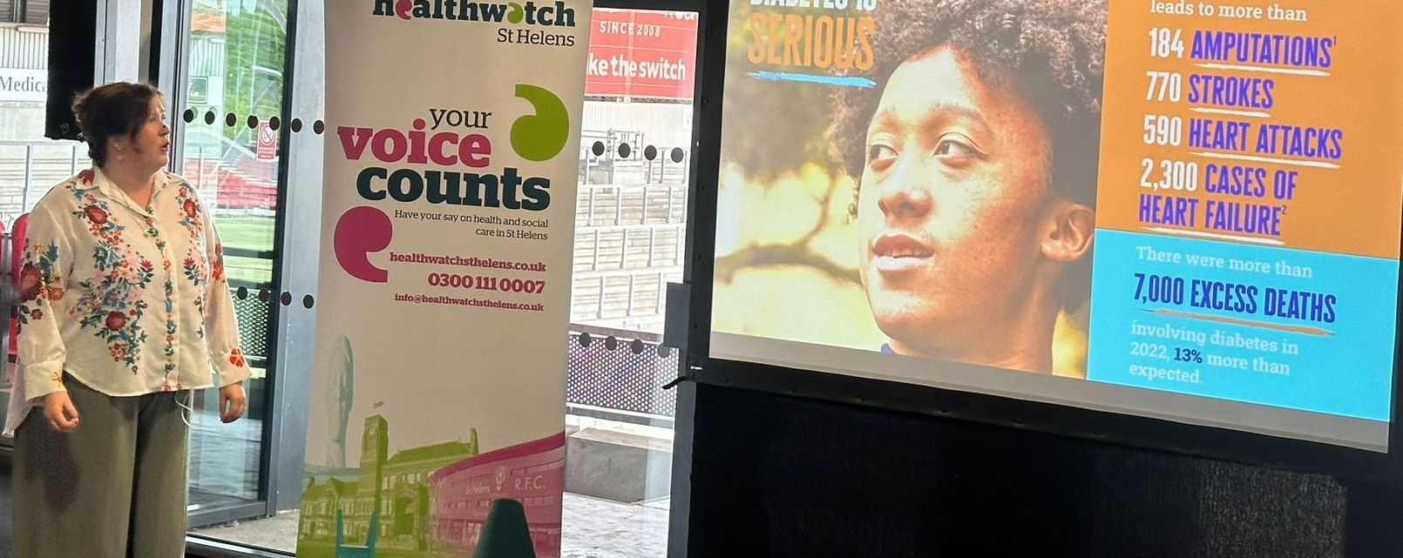
Clare Howarth, Diabetes UK Lead for the North of England gave a very comprehensive presentation about
the situation in St Helens for people with Diabetes.

The Survey

The survey was launched in September 2025 and ran until November 2025. We received 40 responses.

Results from the survey

What you told us:

We used Artificial Intelligence to analyse the feedback from our survey.

Poor GP Support and Delayed Care
A strong theme throughout the feedback is dissatisfaction with GP services, particularly around delayed diagnosis, lack of proactive treatment, and insufficient follow-up care. Several respondents described feeling unsupported, abandoned, or forced to seek help independently.

Examples included:
- Failure to identify or act on symptoms such as high blood pressure
- Lack of communication or advice from GPs
- Patients needing to pursue private consultations themselves
- Low confidence and trust in GP services

Difficulty Accessing Specialist Services
Many respondents reported barriers accessing diabetic specialist services including:
- Podiatry/chiropody
- Diabetic clinics
- Mental health support
- Follow-up appointments

Some patients reported having to arrange services privately due to poor availability within NHS services.

Positive Experiences with Hospital-Based Care
Where specialist or hospital services were accessed, feedback was generally positive. Respondents particularly praised:
- Diabetic eye screening services
- Hospital consultants
- Support from diabetes teams at St Helens Hospital
- Specialist intervention when medication management failed

However, long waiting times for appointments were still highlighted as an issue.

Financial Barriers to Healthy Living
One respondent highlighted the financial challenges of maintaining a healthy diabetic diet, stating that fresh and beneficial foods were unaffordable. This suggests wider socioeconomic factors impacting diabetes management.

Mental Health and Hidden Disabilities
Feedback relating to children with Type 1 diabetes identified gaps in emotional and psychological support. Respondents noted that diabetes can be overlooked when children also have conditions such as ASD or dyslexia.

Key Concerns

Concern | Frequency Mentioned
Poor GP support/lack of confidence in GP | 3
Difficulty accessing podiatry/foot care | 4
Lack of follow-up/contact from diabetic services | 2
Positive hospital/specialist support | 4
Eye screening services mentioned | 4
Long waiting times | 1
Financial barriers to healthy eating | 1
Lack of mental health support | 1

Positive Feedback
Respondents identified several areas of good practice and effective support:
- Diabetic eye screening services were frequently praised
- Hospital consultants and specialist clinics were viewed positively
- St Helens Hospital diabetes support was described as “excellent”
- Residential care settings appeared to provide structured access to screening and podiatry
- Regular blood testing and annual reviews were in place for some patients

Negative Feedback
The most significant negative themes included:
- Delayed diagnosis and lack of treatment by GPs
- Poor communication and lack of patient guidance
- Feeling abandoned or unsupported by services
- Difficulty accessing podiatry and diabetic foot care
- Need to self-refer or pay privately for care
- Long waits for specialist appointments
- Limited mental health support for children with diabetes
- Financial hardship affecting diet and self-management

Conclusions
The feedback suggests significant variation in the quality and accessibility of diabetes support services. While specialist and hospital-based services are generally viewed positively, many respondents expressed frustration with primary care provision, particularly around delayed intervention, communication, and ongoing support.

Access to podiatry services emerged as a consistent concern, with several patients either struggling to obtain appointments or turning to private care. Feelings of abandonment and lack of coordinated follow-up indicate that some patients do not feel adequately monitored or supported once diagnosed.

The findings also highlight wider inequalities affecting diabetes management, including financial barriers to healthy eating and gaps in mental health support for children and young people with additional needs.

Overall, the feedback indicates a need for:
- Improved GP awareness and proactive diabetes management
- Better communication and follow-up pathways
- Increased access to podiatry and specialist services
- Reduced waiting times
- Greater focus on holistic support, including mental health and financial wellbeing

***

Kate’s story

“I was diagnosed as pre-diabetic in 2019 after the condition was flagged up in 2015 and 2016. I was encouraged to go down the control-by-diet route, taking in more exercise and cutting down on sugary foods.

I was also asked to take part in a Diabetic Prevention Programme with other patients as a weekly class event at a local surgery. As most of the patients were of more advanced years, I found this to be a general course where I was weighed once a week, rather than a tailored course. Everyone has different foods that they can eat, different symptoms, so why treat everyone the same?

Parts of the course were too technical for most of the participants, who found it too involved, as did I. I did miss the last two or three classes as I didn’t think I was getting much from them. I then received a rather threatening-sounding letter from the company who were responsible for the course, insinuating that they would inform my GP and there would be consequences for my non-attendance, although I had committed to most of the sessions.

I did respond by phone call to the company, whose name I now cannot remember. I remember being spoken to like a child who had missed school!
At my yearly diabetic review, I have never seen a diabetic nurse, but instead a healthcare professional who seems to go through the same questions every year about whether I drink, smoke, take exercise, etc. There never seems to be any real structure in place.
Sometimes I feel that because I don’t smoke or drink, they seem disappointed that they are unable to tick those boxes and have only my weight to focus on. Sometimes I get the impression that they do not believe what I say.

Recently I was sent for weight loss advice again and was told by the person there that she couldn’t find much wrong with my diet and that I needed to see a diabetic nurse. Since then, I have been put on various medications and asked to increase them at intervals. Some of the medication that I have been taking I am unable to tolerate, so I get put on another with very little follow-up. Some of the medications have bad side effects.

I do have my yearly diabetic eye screening, but I have been told that this may become a two-year appointment from now on. I have blood glucose tests every three months. I attend every six months for eye pressure checks, but they are not interested in the fact that I have diabetes. I don’t understand why that is.
I have never been offered a foot appointment, so I arrange this privately.”

***

Who completed our survey?

Recommendations:

- Primary care providers reassess their own practices with regards to patients who have or might potentially have diabetes.
- Consideration is given to a more joined up way of treating the condition, with a ‘one-stop’ approach to all screening and tests required.
- An holistic approach to treating patients with diabetes, giving consideration to additional challenges such as financial or or emotional/mental health.
- An improvement in communication for patients with diabetes.

Acknowledgements

Thank you to:
- Clare Howarth and other colleagues at Diabetes UK
- Everyone who completed the survey
- Everyone who helped to distribute and promote the survey

The report will be sent to:
- Commissioners and providers
- Public Health St Helens
- The People’s Board
- St Helens Place Partnership Board
- The Health & Social Care Scrutiny Committee
- Healthwatch England

Disclaimer
Please note that the information contained in this report does not reflect the opinions of staff or
volunteers from Healthwatch St Helens. It relates entirely to the views and experiences provided by
members of the public who have shared them with us through various forums, some who wish to
remain anonymous.



Contact us

Healthwatch St Helens

The Beacon, College Street, St Helens, WA10 1TF

Telephone: 0300 111 0007
Email address: info@healthwatchsthelens.co.uk
Website: www.healthwatchsthelens.co.uk

Facebook: facebook.com/@Healthwatchsthelens
Instagram: hw_st_helens

X: @HWStHelens

Independent Complaints Advocacy

Telephone: 01744 456 105

Email: advocacy@healthwatchsthelens.co.uk

