

**Access to Mental Health services for Young People in St Helens.**

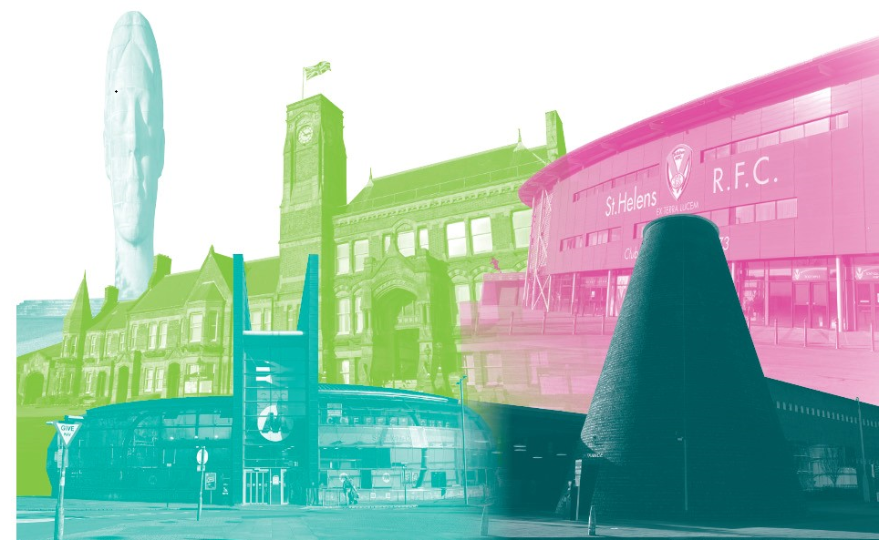

**Background**

We knew there was a lot of work going on across Cheshire & Merseyside to find out young people’s experiences of accessing support for their mental health. We wanted to make sure that we were finding out what our local young people were experiencing.

We designed a survey that gave young people the option to share their stories with us, either anonymously, or they could provide their contact details, and we would contact them to find out more about their experiences.

**What did they tell us?**

* 30% of respondents waited over 12 months for services.
* 53% of respondents didn’t feel listened to by the services they encountered, giving a rating of poor (1 star)
* Interaction with staff received mixed reviews. 20% of respondents rating the staff they encountered as excellent (5 stars), whereas 33% of respondent gave a rating of poor (1 star).
* 53% of respondents gave a poor (1 star) rating for their quality of care and their overall experience.
* 72% of respondents discharged from service had not been signposted to further support.
* Of those waiting to be seen by services, none have been signposted for support during the waiting time.

The respondents who felt listened to and supported were accessing or had accessed the Listening Service run by the YMCA. This service reported the shortest waiting times and highest satisfaction.

100% felt listened to, giving the service a rating of excellent (5 stars) for the staff encountered, quality of care and overall experience.

The survey is illustrated in Appendix 1

**The young people who didn’t feel listened to said:**

* *“Referred to CAMHS and they cancelled me and told I would be referred to a different service” - c*urrently waiting 18 months with no support.
* *“Basically, said they couldn’t help me*” – young person wasn’t signposted to another service.
* “*The system is very broken”* – young person ‘felt patronised and problems were diminished’ – waited 2 yrs for Barnardo’s and deferred twice from CAMHS.
* *“Never received a follow up letter despite calling and asking for it twice”.*
* *“No mental health support was offered and CAMHS response was extremely poor” - young person is now accessing private support.*
* *“No care from people who are supposed to be professional in mental health”.*
* *“This is a tick box”.*
* *“Limited intervention that was little use”.*
* *“Didn’t offer me help, said to go elsewhere”.*
* *“Basically, they said they couldn’t help me”.*
* *“The staff as nice as they were, spoke to my young person in a very patronising way”.*
* *“Feel like a ping pong ball being bounced through services”.*
* *“I felt as if my problems were diminished”.*
* *“Different staff on each occasion asking the same questions, nothing in terms of actually helping them. As a result of the lack of support they have dropped out of university and are now NEET”.*
* *“Services are not set up to help autistic people”.*
* *“Not been able to get a referral to any service so use grassroots mental health at youth club”.*
* *“Patronising and confusing” –*
* *“Had to complain and complaint got upheld but still no support”.*

**The young people who felt listened to said:**

* *“My listener was very nice and listened to me”.*
* *“Extra support offered while waiting for other service”.*
* *“Helped me see things I wouldn’t openly say”.*
* *“Referral came through quickly”.*
* *“Referral to the service at the Beacon came through quickly and was easy to self-refer”.*
* *“School, cadets and the listening service have all been brilliant with their support”.*

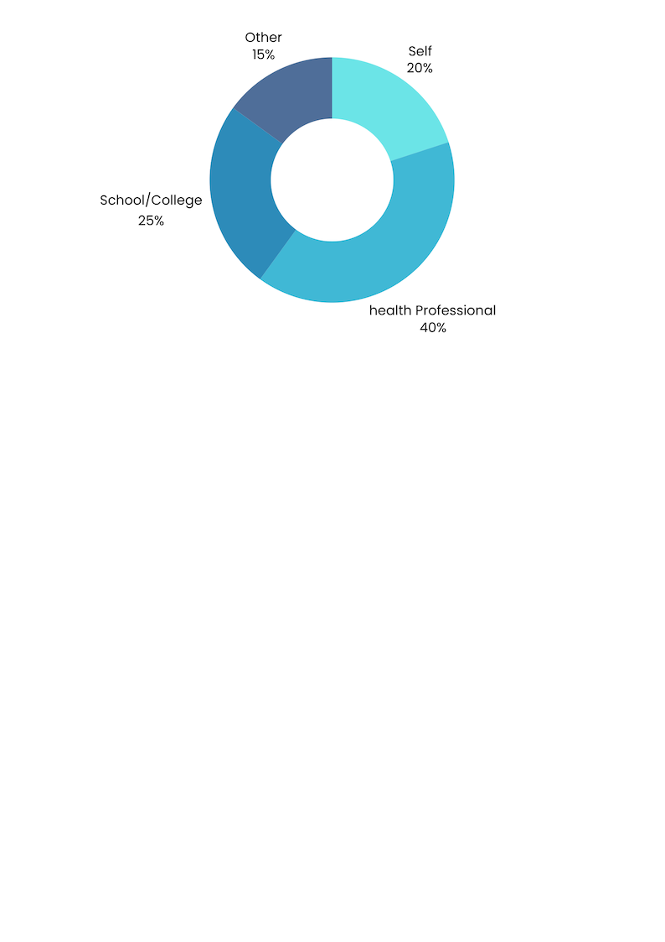Referral made by Time waited to be seen

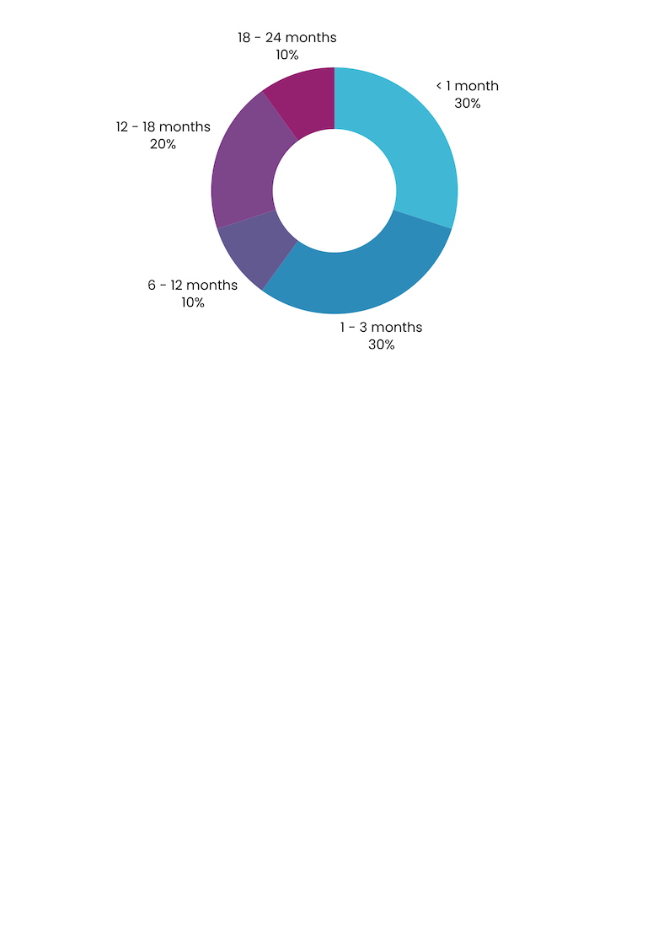

Do you feel the service listened to you? How would you rate the staff you encountered?

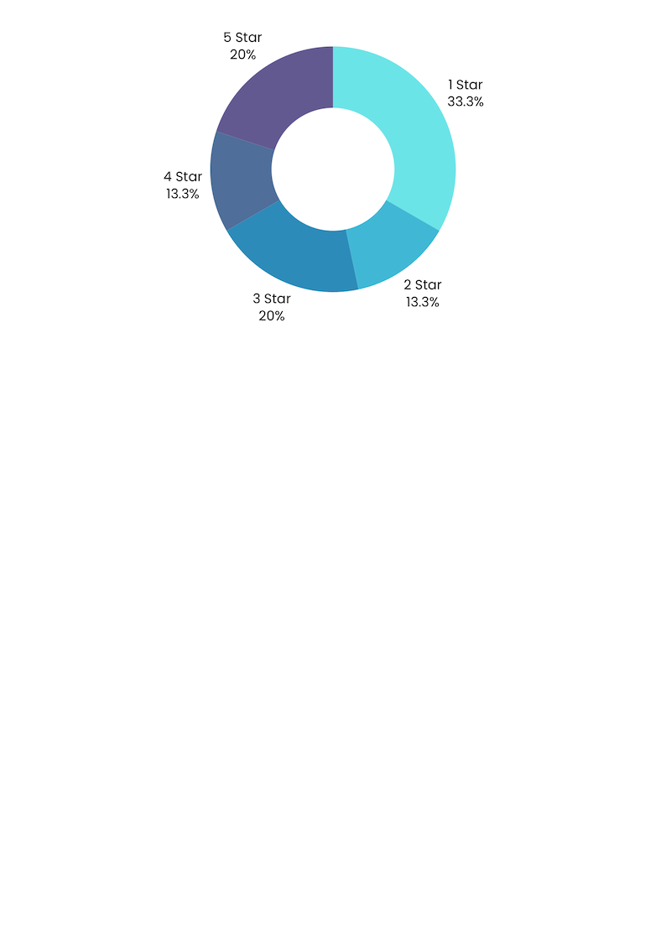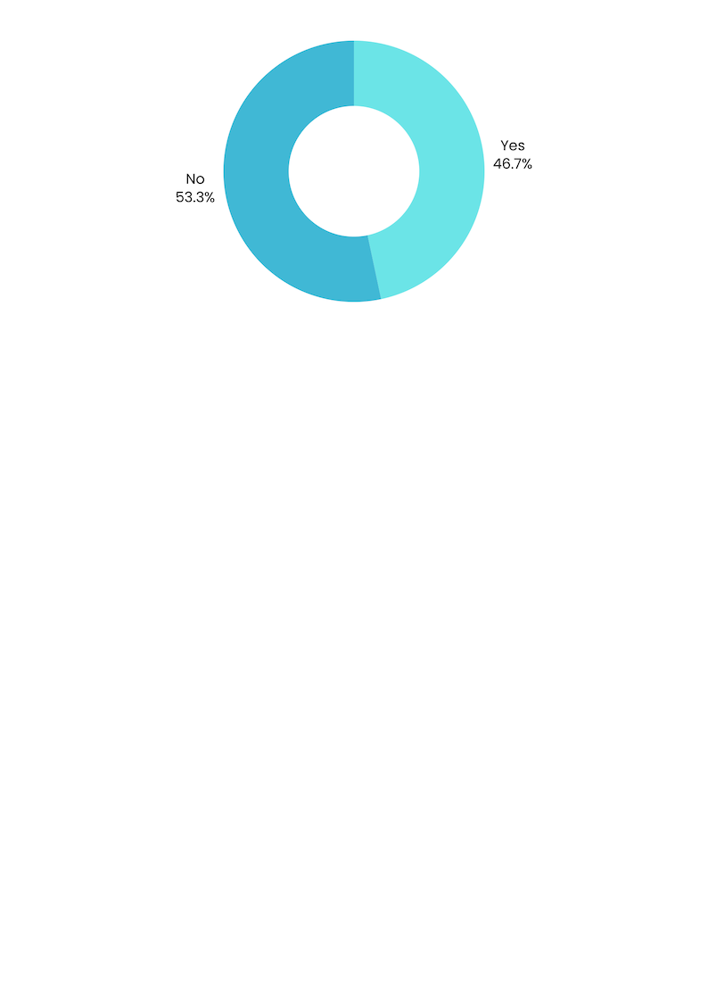

How would you rate your quality of care? How would you rate your overall Experience

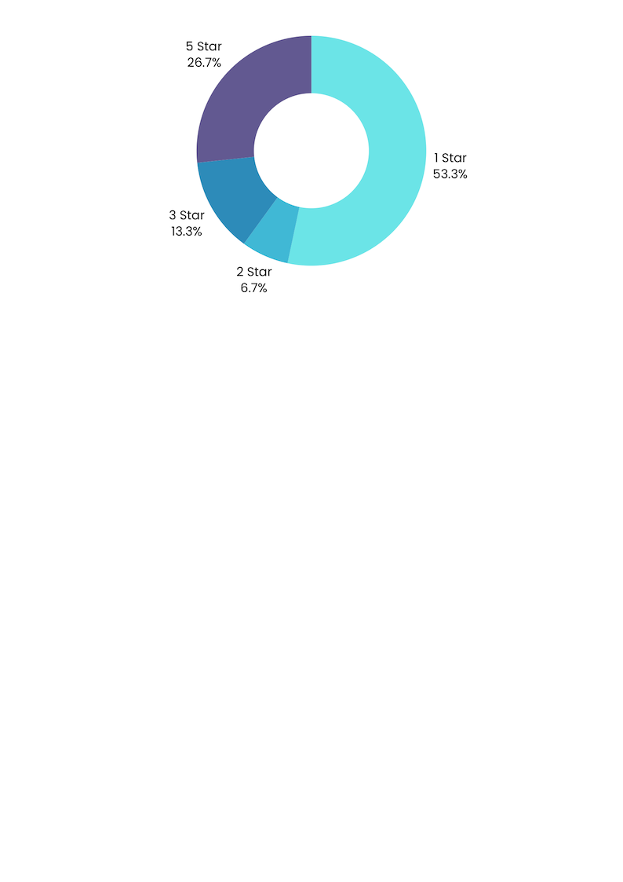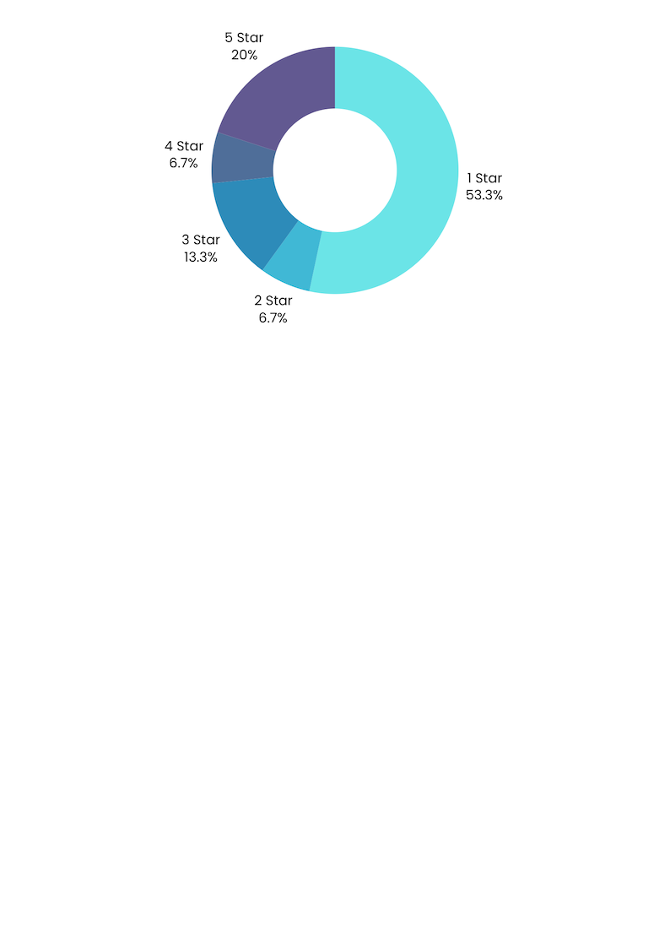

Current status of respondents Of those discharged from service :

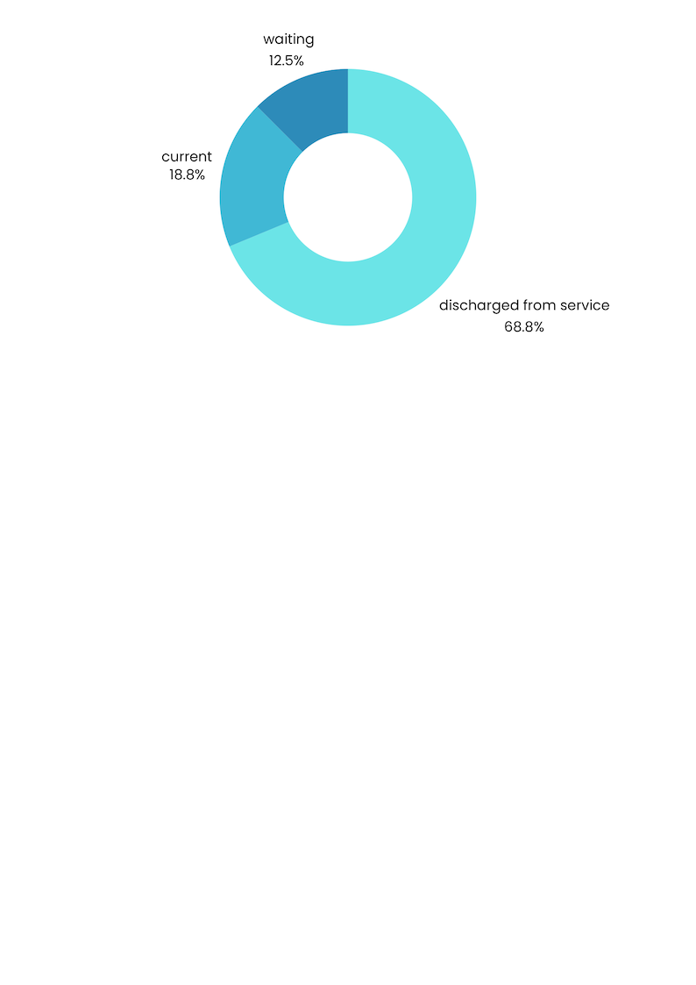

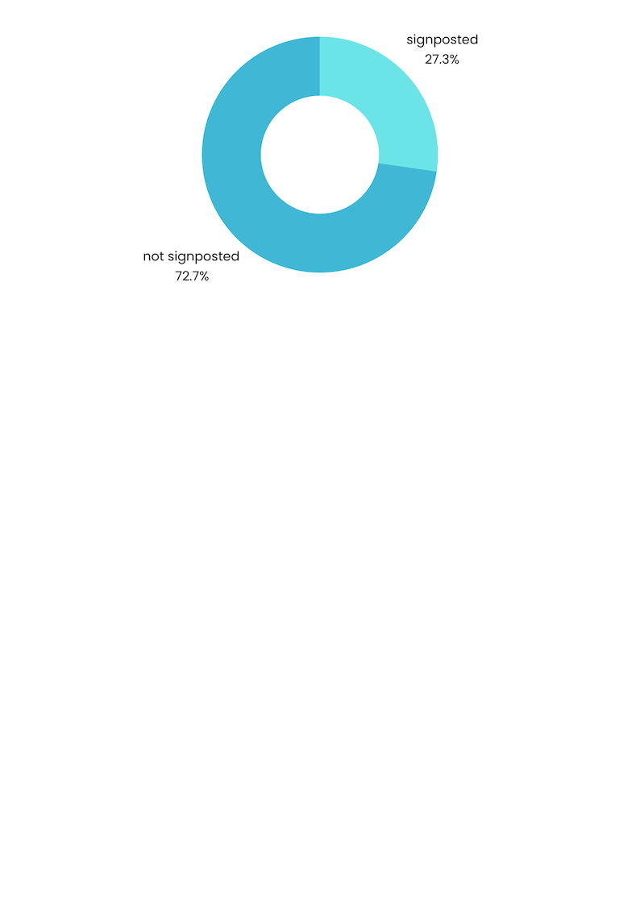

**Summary & Recommendations**

The Mental Health Services in St Helens are in demand. Young people and their parents/carers find the waiting times and then the eligibility to access the services frustrating. Especially if they have other special educational needs.

Young people and their carers have told us that they are not being routinely signposted and are therefore unaware of support and information that could be available to them. There are services, on-line support and information available. To overcome this issue, we would recommend a comprehensive list which is easy to find in a clear logical location, of local and national groups and organisations. This information should be available to all young people, GPs, schools, groups and carers/parents.

A recurring theme shows that young people and their families don’t feel listened to and feel that staff can be patronising. They rate both their care and their experience of the services as poor. This was especially evident in those who are bounced around a number of services. There needs to be a better understanding of service eligibility by those who refer and there is a need to take more ownership of the wellbeing of the young person to ensure they get the support they need.

**Acknowledgements**

We would like to thank:

* The young people and their carers, who completed the survey
* Everyone who shared the survey on our behalf.

**This report will be published on our website, and shared with key partners across the Borough, including commissioners, providers and Healthwatch England.**

**Disclaimer**

Please note that the information contained in this report does not reflect the opinions of staff or volunteers from Healthwatch St Helens. It relates entirely to the views and experiences provided by the young people who answered our survey.

**Appendix 1.**

**At Healthwatch St Helens, we want to hear the experiences of young people, aged 11-25, when accessing mental health services.**

**This will help providers to know what they’re doing well**

**and what needs to improve.**

**Appendix 1**

**Young person’s details (optional, but please tell us age.)**

|  |  |
| --- | --- |
| Name: | Age**:** |
| Gender: | |
| First part your postcode | |
| Do you have a learning difficulty or disability? Yes / No  *If yes, please tell us more about it:* | |
| If you are completing this form out on behalf of someone else:  Relationship to Patient?  Are you a carer? Yes / No | |
| I would like to be anonymous: Yes / No | |
| Would you like to be contacted by the service to discuss your experience?  Yes / No  If yes, please let us have your phone number and/or email address:  Phone number:  Email address: | |

|  |
| --- |
| What service would you like to tell us about?  *(Please provide as much detail as possible, for example Barnardo’s or CAMHS?)* |
| Who made the referral?  □ Self □ Other  □ Health Professional *Please state:*  □ School/College |
| How long did you wait for your referral to come through? |
| Referral time into mental health services:  How long did you wait / have you been waiting to be seen? *(delete as appropriate)* |
| Did you feel the service listened to you? Yes / No  *Can you tell us why?* |
| Have you been discharged from the service? Yes / No  *If yes have you been signposted / referred to another service?* |
| How would you rate the staff you encountered? |
| How would you rate the quality of care? |
| How would you rate your overall experience? |
| Tell us more about your experience |

|  |  |  |
| --- | --- | --- |
|  |  |  |

**Contact us**

**Healthwatch St Helens**

The Beacon, College Street, St Helens, WA10 1TF

Telephone: 0300 111 0007

Email address: info@healthwatchsthelens.co.uk

Website: [**www.healthwatchsthelens.co.uk**](http://www.healthwatchsthelens.co.uk)

Facebook: facebook.com/@Healthwatchsthelens

Instagram: hw_st_helens

X: @HWStHelens

**Independent Complaints Advocacy service**

Telephone: 01744 456 105

Email: [advocacy@healthwatchsthelens.co.uk](mailto:advocacy@healthwatchsthelens.co.uk)

